DESIGN SPECIFICATIONS DOCUMENT

*An automated system for microscope-based, real-time image capture of cancer cells & drug treatment evaluation*

Prepared for:

CytoImage DX

By:

Angeline Alfred

Ashten Bontrager

Huanle Zhou

Timothy Koba

Version 1.0.

*Prototype draft*

Issued:

January 22nd, 2018

TABLE OF CONTENTS

**1** **INTRODUCTION**

1.1 Purpose of The Design Specifications Document………………………………….. 3

1.2 Problem Overview………………………………………………………………….. 3

1.3 Proposed Solution………………………………………………………………….. 3

**2** **DESIGN REQUIREMENTS**

2.1 Hardware Requirements……………………………………………………………. 4

2.2 Software Requirements……………………………………………………………..4

2.3 Documentation Requirements………………………………………………………5

**3** **SYSTEM ARCHITECTURE DIAGRAMS**

3.1 Figure 1. Level 0 Block Diagram…………………………………………………... 5

3.2 Figure 2. Level 1 Block Diagram…………………………………………………... 6

**4****WORKFLOW**

4.1 Workflow Notice…………………………………………………………………… 7

4.2 Gantt Chart…………………………………………………………………………. 7

**5****DESIGN SPECIFICATIONS APPROVAL**………………………………………………... 7

# 

# Introduction

## Purpose of the Design Specifications Document

The purpose of this document is to convey our understanding of what the product must accomplish. It will help identify and clarify misunderstandings concerning the product requirements between the sponsor, CytoImage DX, and the development team. It will also provide the sponsor with insight to our work breakdown.

## Problem Overview

Hematologic malignancies, such as lymphoma, leukemia or myeloma, are the fifth most common type of cancer and fourth most common form of cancer-related death. In the U.S. alone, there are more than 1 million people who suffer from hematologic malignancies, with approximately 150,000 more patients diagnosed every year. Targeted drugs are a driving focus of drug development, but the majority of patients eventually develop resistance, even to these new drugs. As a result, many leukemia patients eventually succumb to their diseases due to resistance to both conventional chemotherapies and newer targeted agents.

In response to this issue, the Oregon Health and Science University along with members of the Knight Cancer Center developed the CytoScreen process to help identify novel drugs that produce complete kill of drug-resistant cancer cells. The CytoScreen is a miniaturized single-cell assay that is performed in multi-well chambers on a fluorescent microscope-imaging platform. It is an ultra-sensitive system that enables imaging of patient blood samples with single-cell granularity.

CytoScreening is a process requiring time-intensive scanning and acquisition of large numbers of images. Because the drug-resistant cells that underlie cancer recurrence are often present at low frequencies (<0.1%) in an individual patient, the majority of the acquired images are not used.

## Proposed Solution

Integrating and/or generating microscopy, image processing, and decision-making software that will automate and conduct real-time selective image acquisition and filtering of the blood sample images using the microscope-computer-camera setup. Only blood sample images containing cancer cells will be retained. Additional images of the cancerous portions of the blood sample will be captured under different monochromatic excitation, filtering (channels), and image depths. These images will be used by CytoImage DX to evaluate the effectiveness of a particular drug treatment.

The software will automatically scan through blood samples on a microscope slide and capture and retain only images of interest, i.e., with cancerous cells present in them. Measuring the fluorescent light intensity of parts of the images it will be determined if cancerous cells are present, based upon a user defined signal-background ratio threshold. This will work because the samples have been tagged with fluorescent dyes for certain properties. When a region of interest is found, images of the same region will be obtained through the remaining five light filters (channels) the Zeiss AxioImager M2 hosts at various image depths. The resulting system will be user-friendly, with a graphical user interface and significantly increase the image acquisition and filtering speed.

# Design Requirements

## HARDWARE REQUIREMENTS

The system should use the following devices in CytoImage DX’s laboratory:

1. **Computer**: Dell precision T3500, with Xeon R CPU 3530 @2.8 GZ, 2 GB RAM. OS: Windows XP professional service pack 3; x32 bit version.
2. **Microscope**: Zeiss AxioImager M2 upright.
3. **XYZ stage**: Marshauser Wetxiar GmbH & Co KG. Type: EK 75x50 mot. Tango CZ EMV
4. **Camera**: Photometric CoolSNAP ES2.
   1. **SOFTWARE REQUIREMENTS**
5. Implementation of open-source automated microscopy software (e.g. micro-manager) to perform rapid microscope-based scanning through blood samples.
6. Implementation of open-source imaging software (e.g. imagej) in the image acquisition and filtering process.
7. Use of an open-source integration platform (e.g. ICY) that performs logical decision-making for feedback to the microscope and controls the selective acquisition of microscopic images based on a preset user established intensity ratio in real-time.
8. Benchmarking the speed and accuracy of the integrated working prototype.
   1. **DOCUMENTATION REQUIREMENTS**
9. Creation of an organized online archive(s), e.g. a GitHub repository, that is easily accessible by the sponsor for viewing ALL things pertaining to the project listed in the subsequent enumerations.
10. The general status of the project updated at least weekly.
11. Dated progress reports listing accomplishments, issues, and future goals after meetings. These should include specific project details, issues, and goals.
12. Providing an updated copy of this ‘Design Specifications Document’ (DSD).
13. If requested by the sponsor, providing documentation that will ease the use or understanding of the developed software, e.g, tutorials, manuals, etc.

# System Architecture Diagrams

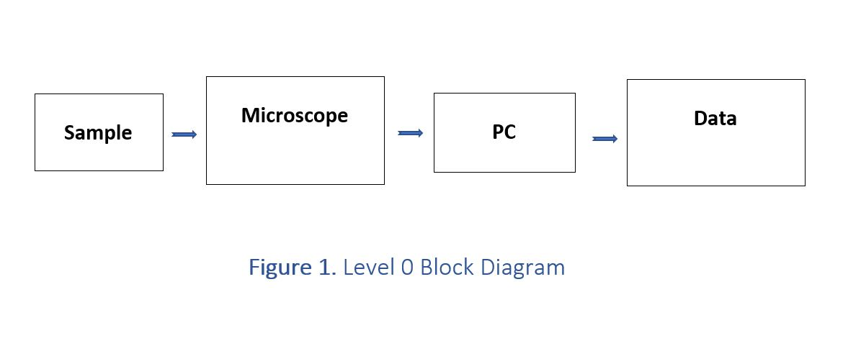

*The above block diagram is a very high level of abstraction of the system architecture. Many process specific details are omitted. Should not be confused with a flowchart.*

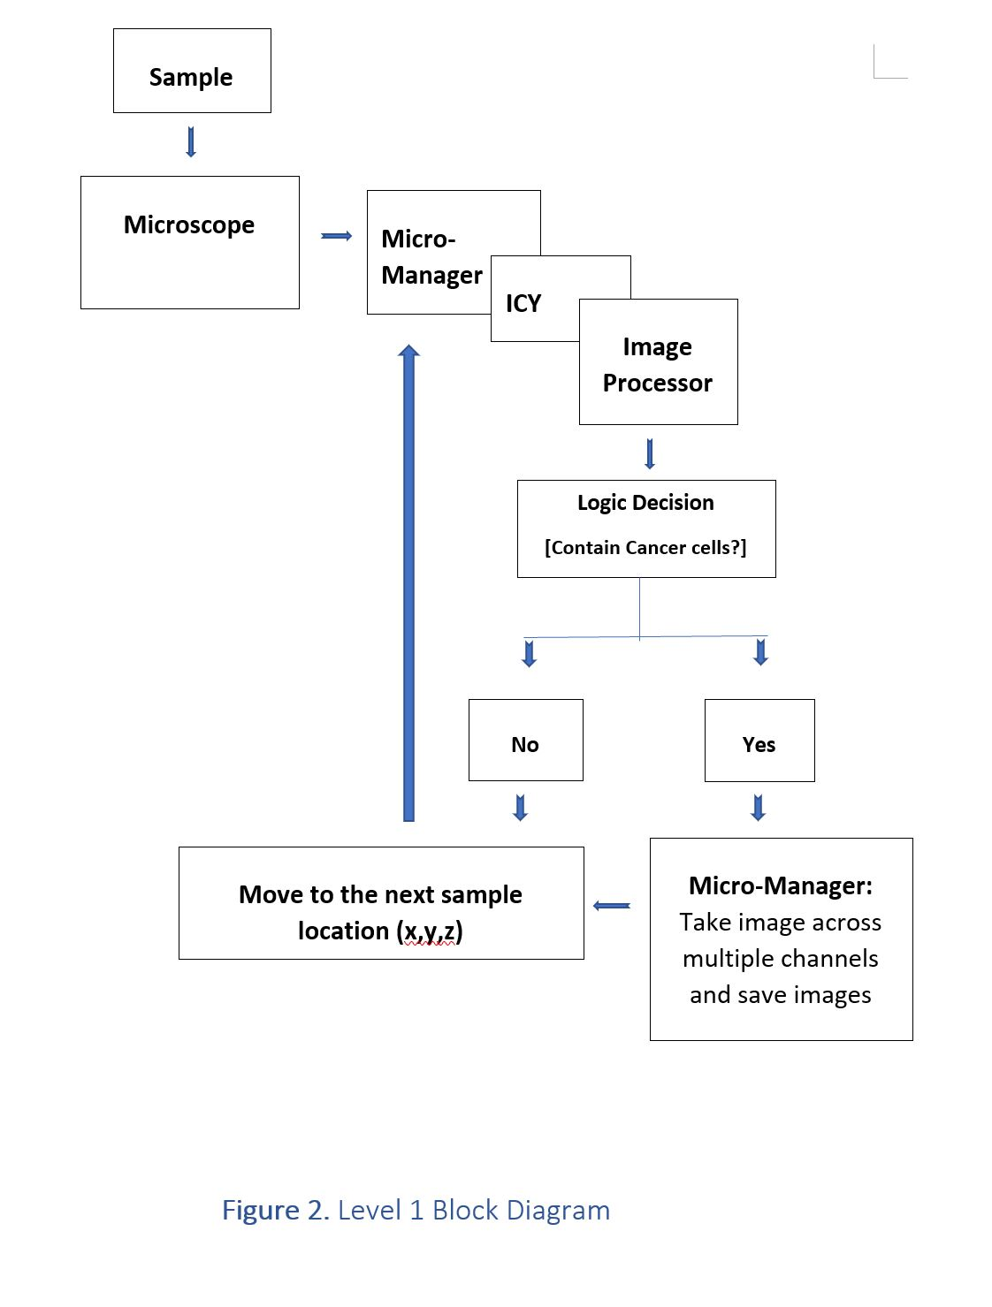

*The above block diagram is more detailed than the Level 0 block diagram. It does not adhere to any block diagram standards.*

# Workflow

* 1. **WORKFLOW NOTICE**

The workflow section is only a preliminary plan. There can be unforeseen setbacks or even advancements that will cause deviations from the schedule proposed in the Gantt chart provide in subsection 4.2. A link to a live Gantt chart will be provided through the GitHub Wiki.

* 1. **GANTT CHART**

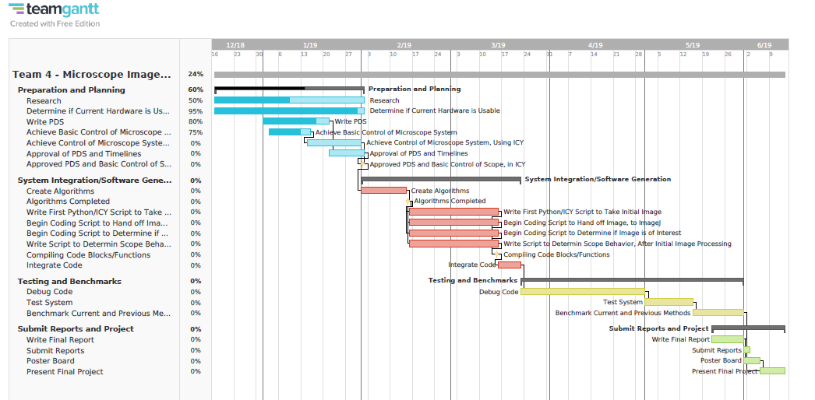

# Design Specifications Approval

The undersigned sponsors acknowledge they have reviewed the **Design Specifications Document** and, by signing, agree that it accurately represents what they want the development team to produce. Any changes to the requirements in this document will be coordinated with and approved by the undersigned representative(s) of CytoImage DX and the development team.

|  |  |  |  |
| --- | --- | --- | --- |
| Signature: |  | Date: |  |
| Print Name: |  |  |  |
| Title: |  |  |  |
| Role: |  |  |  |

|  |  |  |  |
| --- | --- | --- | --- |
| Signature: |  | Date: |  |
| Print Name: |  |  |  |
| Title: |  |  |  |
| Role: |  |  |  |

|  |  |  |  |
| --- | --- | --- | --- |
| Signature: |  | Date: |  |
| Print Name: |  |  |  |
| Title: |  |  |  |
| Role: |  |  |  |

|  |  |  |  |
| --- | --- | --- | --- |
| Signature: |  | Date: |  |
| Print Name: |  |  |  |
| Title: |  |  |  |
| Role: |  |  |  |

|  |  |  |  |
| --- | --- | --- | --- |
| Signature: |  | Date: |  |
| Print Name: |  |  |  |
| Title: |  |  |  |
| Role: |  |  |  |

|  |  |  |  |
| --- | --- | --- | --- |
| Signature: |  | Date: |  |
| Print Name: |  |  |  |
| Title: |  |  |  |
| Role: |  |  |  |